**Classification of Arrhythmia by Using Deep Learning with 2-D ECG Spectral Image Representation.**

ABSTRACT:

The electrocardiogram (ECG) is one of the most extensively employed signals used in the diagnosis and prediction of cardiovascular diseases (CVDs). The ECG signals can capture the heart’s rhythmic irregularities, commonly known as arrhythmias. A careful study of ECG signals is crucial for precise diagnoses of patients’ acute and chronic heart conditions. In this study, we propose a two-dimensional (2-D) convolutional neural network (CNN) model for the classification of ECG signals into eight classes; namely, normal beat, premature ventricular contraction beat, paced beat, right bundle branch block beat, left bundle branch block beat, atrial premature contraction beat, ventricular flutter wave beat, and ventricular escape beat. The one-dimensional ECG time series signals are transformed into 2-D spectrograms through short-time Fourier transform. The 2-D CNN model consisting of four convolutional layers and four pooling layers is designed for extracting robust features from the input spectrograms. Our proposed methodology is evaluated on a publicly available MIT-BIH arrhythmia dataset. We achieved a state-of-the-art average classification accuracy of 99.11%, which is better than those of recently reported results in classifying similar types of arrhythmias. The performance is significant in other indices as well, including sensitivity and specificity, which indicates the success of the proposed method.

INTRODUCTION:

Cardiovascular diseases (CVDs) are the leading cause of human death, with over 17 million people known to lose their lives annually due to CVDs [1]. According to the World Heart Federation, three-fourths of the total CVD deaths are among the middle and low-income segments of the society [2]. A classification model to identify CVDs at their early stage could effectively reduce the mortality rate by providing a timely treatment [3]. One of the common sources of CVDs is cardiac arrhythmia, where heartbeats are known to deviate from their regular beating pattern. A normal heartbeat varies with age, body size, activity, and emotions. In cases where the heartbeat feels too fast or slow, the condition is known as palpitations. An arrhythmia does not necessarily mean that the heart is beating too fast or slow, it indicates that the heart is following an irregular beating pattern. It could mean that the heart is beating too fast—tachycardia (more than 100 beats per minute (bpm)), or slow—bradycardia (less than 60 bpm), skipping a beat, or in extreme cases, cardiac arrest. Some other common types of abnormal heart rhythms include atrial fibrillation, atrial flutter, and ventricular fibrillation.

The electrocardiogram (ECG) recordings are widely used for diagnosing and predicting cardiac arrhythmia for diagnosing heart diseases. Towards this end, clinical experts might need to look at ECG recordings over a longer period of time for detecting cardiac arrhythmia. The ECG is a one-dimensional (1-D) signal representing a time series, which can be analyzed using machine learning techniques for automated detection of certain abnormalities. This representation could allow the application of CNN architectures (designed to operate on 2-D inputs) for development of automated systems related to CVDs.

CONTRIBUTION:

1. Spectrograms (2-D images) are employed, which are generated from the 1-D ECG signal using STFT. In addition, data augmentation was used for the 2-D image representation of ECG signals.

2. A state-of-the-art performance was achieved in ECG arrhythmia classification by using the proposed CNN-based method with 2-D spectrograms as input.

PROPOSED SCHEME:

A schematic representation of the proposed scheme is presented in Figure 1. The method consists of five steps, i.e., signal pre-processing, generation of 2-D images (spectrograms), augmentation of data, extraction of features from the data (using the CNN model), and its classification based on the extracted features. The details of these steps are presented in the following subsections.

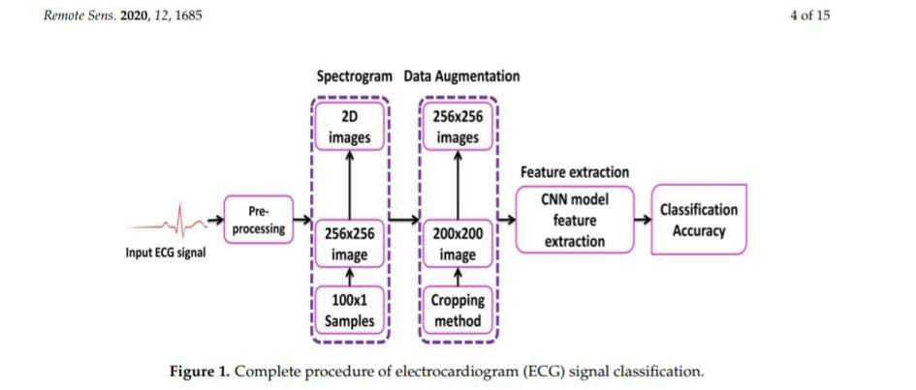

PRE PROPOSING:

The wavelet thresholding was performed using,

ωx,y = {sgn (ωx,y) |ωx,y| − λ /exp3 [α(|ωx,y|−λ)/λ] }, | ωx,y| ≥ λ

{0, |ωx,y| < λ

DATA AUGMENTATION:

The proposed CNN model works on 2-D images of ECG signals as input data, which allows changing the image size with operations such as cropping. Such augmentation methods would add to the training data and hence would allow better training of the CNN model. Another important issue that arises when using small data with CNN based architectures is overfitting. Data augmentation is a way to deal with overfitting and allows better training of a CNN model. For imbalanced data, data augmentation can help in maintaining a balance between different classes. We have used the cropping method for the augmentation of seven classes of ECG beats; namely, premature ventricular contraction beat (PVC), paced beat (PAB), right bundle branch block beat (RBB), left bundle branch block beat (LBB), atrial premature contraction beat (APC), ventricular flutter wave (VFW), and ventricular escape beat (VEB). As a result of cropping, we obtain multiple ECG spectrograms of reduced size (200 × 200), which are then resized to 256 × 256 images (using linear interpolation) before being fed into the CNN. This resulted in an eight times increase in the training data, which benefited the training process.

DATA NEUTRAL NETWORK:

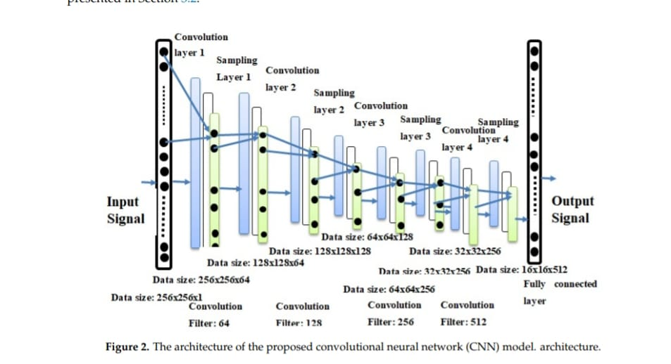

EXPERIMENTS:

**Data set**:

The MIT-BIH arrhythmia dataset consists of 48 records, each having an approximate duration of 30 minutes recorded from a two-channel ambulatory system, collected between 1975 and 1979 [50]. Twenty-three recordings were selected at random from 4000 long term Holter recordings composed of a diverse group of inhabitants of indoor patients (60%) as well as outdoor patients (40%). Twenty-five recordings were chosen from a similar set, with a focus on complex ventricular, junctional, and supra-ventricular arrhythmias. These recordings were digitized at 360 samples/sec for each channel with a resolution of 11-bits over a range of 10 mV. A minimum of two cardiologists were involved in annotating each record and recorded the issues and corresponding solutions needed to reach to the computer-readable outcome. Hence, for the records, approximately 110,000 explanations were documented in this database.

**Deep neural network parameters:**

The performance of the proposed CNN algorithm was compared with AlexNet and VGGNet architectures [48] in terms of the ECG arrhythmia classification. The regular normal beat (NOR) and seven other types of cardiac arrhythmia (VFW, PVC, VEB, RBB, LBB, PAB, and APC) classes were selected from the MIT-BIH arrhythmia database.

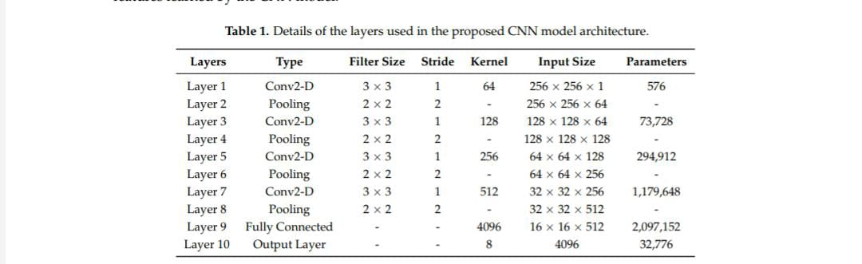

EXPERIMENTAL SETUP:

The proposed CNN classifier was implemented in Python with the open source library Tensor Flow [51], which was developed by Google for deep learning. Substantial computational power and training time were needed to train the CNN model. The experimental setup consisted of an eighth-generation ASUS server with 32GB internal RAM, 500 GB external SSD hard drive with the addition of internal hard drive, and NVIDIA 1080 GPU with 11GB memory. The 2-D spectral images were divided such that 70% of the data was used for training, 30% for test. A 5-fold cross validation was used during the training process. The train/test splits were generated such that there was no overlap between the two splits.

EVALUATION PARAMETERS:

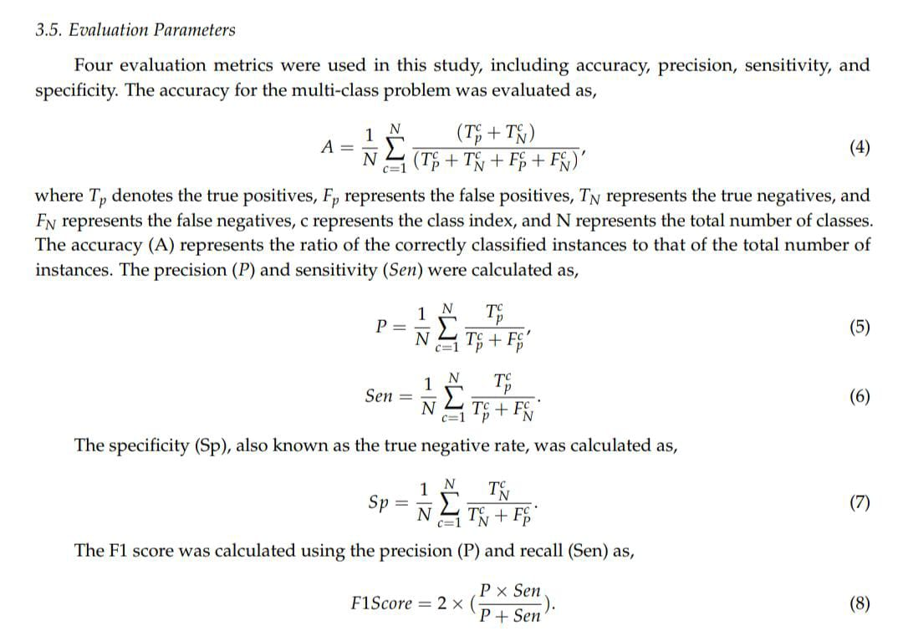

RESULT:

The two significant optimization parameters in the proposed 2-D CNN model are the learning rate and the batch size of the data used. To improve the performance, these two optimization parameters must be selected carefully to obtain the best accuracy in the automatic classification of arrhythmia using the ECG signals. The proposed model was evaluated in different experiments with various values of learning parameters. For a smaller value of the learning rate (i.e., less than 0.0005), the speed of the convergence was very slow. However, when the value of the learning rate was large (i.e., greater than 0.001), the speed of convergence improved. At the same time, asymmetrical changes were observed in the accuracy rate. Henceforth, we selected an optimum value of 0.001 for the learning rate, as this value can attain better accuracy for the proposed model (i.e., optimum value).

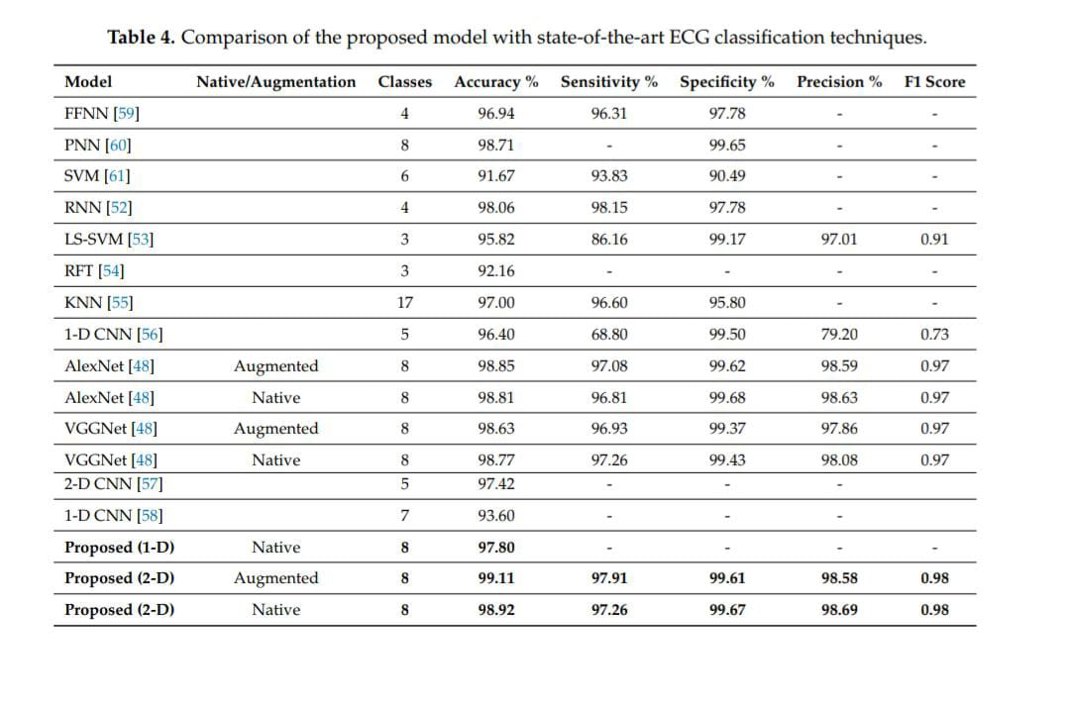

CONCLUSION:

In this study, we proposed a 2-D CNN-based classification model for automatic classification of cardiac arrhythmias using ECG signals. An accurate taxonomy of ECG signals is extremely helpful in the prevention and diagnosis of CVDs. Deep CNN has proven useful in enhancing the accuracy of diagnosis algorithms in the fusion of medicine and modern machine learning technologies. The proposed CNN-based classification algorithm, using 2-D images, can classify eight kinds of arrhythmia, namely, NOR, VFW, PVC, VEB, RBB, LBB, PAB, and APC, and it achieved 97.91% average sensitivity, 99.61% specificity, 99.11% average accuracy, and 98.59% positive predictive value (precision). These results indicate that the prediction and classification of arrhythmia with 2-D ECG representation as spectrograms and the CNN model is a reliable operative technique in the diagnosis of CVDs. The proposed scheme can help experts diagnose CVDs by referring to the automated classification of ECG signals. The present research uses only a single-lead ECG signal. The effect of multiple lead ECG data to further improve experimental cases will be studied in future work.

REFERENCE:

1. Mc Namara, K.; Alzubaidi, H.; Jackson, J.K. Cardiovascular disease as a leading cause of death: How are pharmacists getting involved? Integr. Pharm. Res. Pract. 2019, 8, 1.

2. Lackland, D.T.; Weber, M.A. Global burden of cardiovascular disease and stroke: hypertension at the core. Can. J. Cardiol. 2015, 31, 569–571.

3. Mustaqeem, A.; Anwar, S.M.; Majid, M. A modular cluster based collaborative recommender system for cardiac patients. Artif. Intell. Med. 2020, 102, 101761.

4. Irmakci, I.; Anwar, S.M.; Torigian, D.A.; Bagci, U. Deep Learning for Musculoskeletal Image Analysis. arXiv Prepr. 2020, arXiv:2003.00541.